Name ___________________________ Period ________
3rd Quarter Independent Book Project
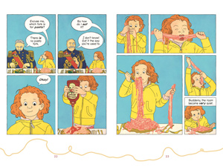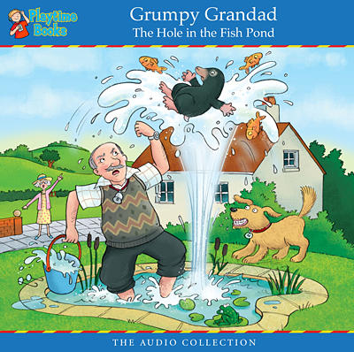
Create a Comic book, Graphic novel, or Children’s Story

Assignment: Choose the genre of writing you would best like to use (comic book, graphic novel, or children’s story) to show your knowledge of a book you read. Consider its plot as you decide. You may use technology to complete this project.
Use the rubric for specific guidelines for each genre.
Graphic novel/Comic book: Make a graphic novel or comic book version of an important scene in the book. Write a paragraph explaining the scene’s importance.
Children’s Story: Turn the novel you read into a children's story by retelling the plot in a simple way with vocabulary appropriate for youngsters. Make sure your creation looks like a children's book, complete with an appealing cover including a picture, the title, and the author, and colorful illustrations above and below your writing on each page.

I have seen my child reading the book for this project recently. ______________________ Parent signature

